Club Growth Director 2026–2027
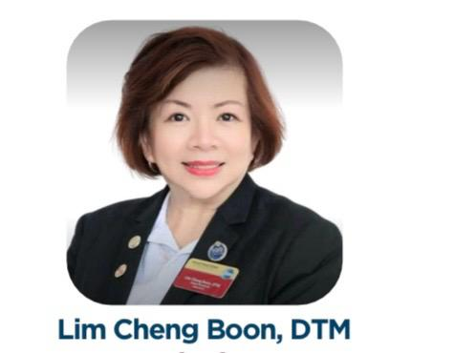
District 80 · Toastmasters International ·
LIM CHENG BOON, DTM

Dear Fellow Toastmasters Members,
I am Lim Cheng Boon, a member of Eunos Mandarin Toastmasters Club, Toa Payoh East Tong Zhou Mandarin Toastmasters Club, and Encantada All Ladies Toastmasters Club.
I am deeply honoured to have been nominated by the District Leadership Committee (DLC) and confirmed as a candidate for Club Growth Director for the term 2026–2027.
Toastmasters International has transformed me—from a new member to a district leader, I have grown through learning and evolved through service. I now hope to channel this growth into meaningful impact: empowering more clubs and inspiring more members.
I. My Journey in Service

Year · | Role / Achievement
A. | Leadership & Contests
2021–2022 | Vice President Education (VPE), Eunos Mandarin TMC
2022–2023 | President, Eunos Mandarin TMC
2022–2023 | Area Director, Area L2
2024-2025 | Vice President Membership (VPM), Eunos Mandarin TMC
2024-2025 | Vice President Membership (VPM), Encantada All-Ladies TMC
2025-2026 | Secretary, Eunos Mandarin TMC
2025-2026 | Vice President Public Relation (VPR), Encantada All-Ladies TMC
2021–2022 | Area L2 Speech Contest Champion
2021–2022 | Area L2 Table Topics Contest Champion
2023–2024 | Area L2 Table Topics Contest Champion
2022–2023 | ⭐ District 80 Area Director of the Year
B. | Club Coach / Advisor
2022–2023 | Club Coach, Toa Payoh East Tong Zhou Mandarin TMC
2024–2026 | Advisor, Toa Payoh East Tong Zhou Mandarin TMC
2024–2025 | Advisor, Telok Blangah Mandarin TMC
2025 | ⭐ Tong Zhou: Perfect 10 DCP & President's Distinguished Club Award (D80 AC 2025)
C. | District 80 Club Growth Team
2023–2024 | Club Retention Chair
2023–2024 | ⭐ District 80 Service Excellence Award
D. | District 80 PQ Team
2024–2025 | Pathways Lead, PQD Team
2024–2025 | Annual Conference (AC) Co-Chair
2024–2025 | Organizer & Trainer: COT1, COT2 & Pathways Workshops
E. | Senior District Officer
2025–2026 | District Administration Manager
Aug 2025 | ⭐ Spearheaded release of District 80 Directory (31 Aug)

II. Strategic Focus for 2026–2027

Collaborative Approach: I firmly believe that great results come from great teamwork. If elected, I will work closely with the Program Quality Director (PQD) and District Director (DD) to align club growth efforts with the district's overall mission—ensuring every initiative is purposeful, coordinated, and impactful.
1. Strengthening Club Foundations
Through structured mentoring and dedicated resource support, I will enhance member engagement and build clubs that are both sustainable and resilient.
2. Expanding the Membership Base
By curating attractive themed program and strategic outreach campaigns, we will attract new members, retain existing ones, and support their development.
3. Driving New Club Growth
By bringing Toastmasters into workplaces, communities, and institutions, we can ignite communication and leadership growth in more lives across Singapore.
Pave the way with service, Shine the light with growth — Let every club sparkle with purpose!
I believe growth is not just about numbers—it is about building culture, empowering leadership, and enabling transformation.
Dear all, let's walk this journey together. Together, let's empower every club to grow, shine, and thrive!
If you have any ideas or feedback, please feel free to reach out via email or WhatsApp. Thank you for your support—I look forward to seeing you at DCM 2 on 2 May 2026.
Lim Cheng Boon, DTM
Candidate for Club Growth Director 2026–2027
📞 +65 9671 0068 📧 Cheng_Boon_Lim@yahoo.com.sg
To learn more about all nominees: https://www.d80toastmasters.org/dlc-nominations

